Hong Kong Exchanges and Clearing Limited and The Stock Exchange of Hong Kong Limited take no responsibility for the contents of this announcement, make no representation as to its accuracy or completeness and expressly disclaim any liability whatsoever for any loss howsoever arising from or in reliance upon the whole or any part of the contents of this announcement.
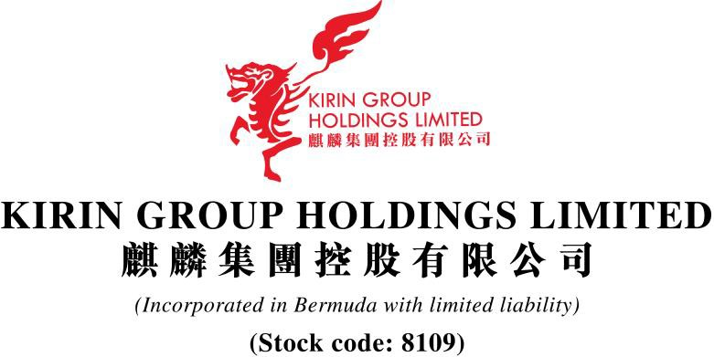

(In Compulsory Liquidation)

QUARTERLY UPDATE ANNOUNCEMENT

The announcement is made by Kirin Group Holdings Limited (the “Company”) pursuant to Rule 17.26A of the Rules Governing the Listing of Securities on the GEM of the Stock Exchange of Hong Kong Limited (the “Stock Exchange”) (the “Listing Rules”) and the Inside Information Provisions (as defined under the Listing Rules) under Part XIVA of the Securities and Futures Ordinance (Chapter 571 of the Laws of Hong Kong).

References are made to the announcements of the Company dated 14 December 2021, 7 January 2022, 12 May 2022 and 25 May 2022 (collectively “the Announcements”) in respect of the winding-up order made against the Company and the resumption guidance. Unless otherwise defined herein, capitalized terms used in this announcement shall have the same meanings as those defined in the Announcements.

UPDATE ON BUSINESS OPERATIONS

The Liquidators are still taking steps to ascertain the status of the Company’s business operations. Further announcements will be made by the Company to provide updates on the business operations of the Company as and when required.

UPDATE ON APPOINTMENT OF LIQUIDATORS

As disclosed in the announcement of the Company dated 12 May 2022, pursuant to the Regulating Order of the High Court dated 29 April 2022, Messrs. Osman Mohammed Arab and Wong Kwok Keung, both of RSM Corporate Advisory (Hong Kong) Limited, were appointed Joint and Several Liquidators of the Company.

UPDATE ON THE ADDITIONAL RESUMPTION GUIDANCE

As disclosed in the Announcements, the Stock Exchange sets out the following conditions for the resumption of trading in the shares of the Company:

- having the Winding-up Order withdrawn or dismissed and liquidator discharged;
- demonstrating compliance with Rule 17.26 of the Listing Rules;
- informing the market of all material information for the Company’s shareholders and
investors to appraise the Company’s Position;
- publish all outstanding financial results and address any audit modification(s);
- re-comply with Rules 5.05, 5.05A, 5.28, 5.34 and 5.36A of the Listing Rules; and
- re-comply with Rule 5.14 of the Listing Rules.

The Stock Exchange indicated that it may modify or supplement the resumption guidance that has been given and/or give further guidance if the Company’s situation changes.

If the Company fails to remedy the issue(s) causing its trading suspension, fully comply with the Listing Rules to the Stock Exchange’s satisfaction and resume trading in its shares by 12 December 2022, the Listing Division will recommend the GEM Listing Committee to proceed with the cancellation of the Company’s listing. Under Rule 9.15 of the Listing Rules, the Stock Exchange also has the right to impose a shorter specific remedial period, where appropriate.

As at the date of this announcement, there is no update on the resumption progress.

Further announcement will be made by the Company to provide updates on the resumption progress as and when appropriate.

CONTINUED SUSPENSION OF TRADING

Trading in the shares of the Company on the Stock Exchange has been suspended with effect from 11:58 a.m. on 13 December 2021 and will remain suspended until further notice.

For and on behalf of
Kirin Group Holdings Limited
(In Compulsory Liquidation)
Osman Mohammed Arab
Wong Kwok Keung
Joint and Several Liquidators
Acting as agents of the Company
without personal liabilities

Hong Kong, 21 June 2022

As at the date of this announcement, the Board comprises Mr. Wang Jinhan, Mr. Zhou Wenjun, Mr. Wang Jiankun, Mr. Hung Tat Chi Alan and Mr. Zhang Yang as the executive Directors, Mr. Lee Cheung Yuet Horace as the independent non-executive Director.

The affairs, business and property of the Company are being managed by the Joint and Several Liquidators who act as agents of the Company only and without personal liabilities.

