The Stock Exchange takes no responsibility for the contents of this announcement, makes no representation as to its accuracy or completeness and expressly disclaims any liability whatsoever for any loss howsoever arising from or in reliance upon the whole or any part of the contents of this announcement.

中 保 國 際 控 股 有 限 公 司
CHINA INSURANCE INTERNATIONAL HOLDINGS COMPANY LIMITED
(Incorporated in Hong Kong with limited liability)

MAJOR AND CONNECTED TRANSACTION

Financial adviser to China Insurance International Holdings Company Limited


Cazenove Asia Limited

SUMMARY

On 4 September 2001, the Company entered into the Reorganisation and Share Transfer Agreement with CICL and Tai Ping Life, pursuant to which the Company has conditionally agreed, among other things, to acquire, and/or to nominate a wholly-owned subsidiary or subsidiaries established outside the PRC and Hong Kong to acquire, in aggregate 62.5% interest in Tai Ping Life from CICL for a total consideration of approximately HK$522.4 million. Approximately HK$242.4 million of the consideration for the Proposed Share Transfer will be satisfied by the issuance and allotment of the Consideration Shares to CIHK at the direction of CICL and the balance of HK$280 million will be satisfied by the payment of a cash amount which will be funded by the net proceeds of approximately HK$214 million raised from the placing and subscription announced by the Company on 30 July 2001 and from the Company's internal resources.

Subject to the terms and conditions of the Reorganisation and Share Transfer Agreement, the Company has also agreed that on CICL's instruction which may be given at any time after Completion, it will, together with CICL, transfer or procure the Designated Subsidiary to transfer the Strategic Investor Interest to the Strategic Investor (or the SI Subsidiary) at such time and for such consideration (provided that it shall not be less than the relevant consideration paid by the Company to CICL) as CICL considers appropriate. It is currently intended that the proceeds received by the Company or its Designated Subsidiary from the disposal of the Strategic Investor Interest (if any) will be used for long term investment purpose. The Company will comply with the Listing Rules and will make a further announcement regarding such transfer of Strategic Investor Interest as and when required under the Listing Rules.

Tai Ping Life was established in the PRC and is owned as to 100% by CICL. The resumption of Tai Ping Life's personal insurance businesses (including life insurance) throughout the PRC was approved by the CIRC on 22 May 2001 with the consent of the State Council of the PRC. At present, there are only five nationwide insurance companies in the PRC carrying on life insurance business throughout the PRC.

As CICL owns a 100% interest in CIHK (of which a 20% interest is held through TPI and CLIC), and CIHK is a controlling shareholder of the Company, CICL is an associate of CIHK and the Proposed Share Transfer therefore constitutes a connected transaction of the Company for the purpose of the Listing Rules. As the 100% value of Tai Ping Life exceeds 50% of the consolidated net tangible asset value of the Company as disclosed in its latest published annual report adjusted to take into account of the net proceeds from the issues of Shares as announced on 2 May 2001 and 30 July 2001 and the unaudited net profit of the Company for the 6 months ended 30 June 2001, the Proposed Share Transfer also constitutes a major transaction for the Company for the purpose of the Listing Rules.

The Proposed Share Transfer is subject to, among other things, the approval of the Independent Shareholders. In view of the interest of CICL in the Proposed Share Transfer, CIHK and its associates will abstain from voting at the EGM in this regard. A circular containing, among other things, information on the Proposed Share Transfer, the relevant accountants' report of Tai Ping Life, the letter from the independent financial adviser and the recommendation of the Independent Board Committee in relation to the Proposed Share Transfer will be dispatched to the Shareholders as soon as practicable.

Cazenove Asia Limited has been appointed as the financial adviser to advise the Company on this transaction and an independent financial adviser will be retained to advise the Independent Board Committee.

1. REORGANISATION AND SHARE TRANSFER AGREEMENT DATED 4 SEPTEMBER 2001

Parties

i. CICL as the vendor

ii. the Company as the purchaser

iii. Tai Ping Life

Proposed Share Transfer

Pursuant to the Reorganisation and Share Transfer Agreement, the Company has conditionally agreed, among other things, to acquire, and/or to nominate the Designated Subsidiary to acquire, in aggregate 62.5% interest in Tai Ping Life from CICL for a total consideration of approximately HK$522.4 million, of which approximately HK$242.4 million is to be satisfied by the issuance and allotment of the Consideration Shares by the Company to CIHK at the direction of CICL and the balance of HK$280 million is to be satisfied by a cash payment to CICL.

The terms of the Reorganisation and Share Transfer Agreement (including the consideration payable by the Company pursuant thereto) have been determined after arm's length negotiations between the Company and CICL. Further details in relation to the terms of the Reorganisation and Share Transfer Agreement, including the consideration payable, are set out below.

The Directors consider that the terms of the Reorganisation and Share Transfer Agreement are based on normal commercial terms and are fair and reasonable so far as the Shareholders are concerned.

Consideration

The total consideration payable by the Company to CICL for the 62.5% interest in Tai Ping Life under the Reorganisation and Share Transfer Agreement is approximately HK$522.4 million. Upon completion of the Reorganisation and Share Transfer Agreement, approximately HK$242.4 million of the consideration will be satisfied by the issuance and allotment of approximately 78.5 million Shares credited as fully paid to CIHK at the direction of CICL at the agreed issue price of HK$3.0875 per Share and the balance of HK$280 million will be satisfied by the payment of a cash amount which will be funded by the net proceeds of approximately HK$214 million raised from the placing and subscription announced by the Company on 30 July 2001 and from the Company's internal resources.

The Consideration Shares will rank pari passu in all respects with the then existing issued Shares. The issue price of the Consideration Shares represents a 5.3% discount to the average closing price of the Shares at HK$3.26 for the ten trading days ended on 3 September 2001, being the last trading date prior to the date of the Reorganisation and Share Transfer Agreement. Such issue price also represents a 5.0% discount to the closing price of the Shares at HK$3.25 on 3 September 2001. The Consideration Shares represent about 7.64% of the existing issued share capital of the Company and about 7.10% of the issued share capital of the Company as enlarged by the issue of the Consideration Shares pursuant to the Proposed Share Transfer.

The Directors consider that taking into account of the business potential of Tai Ping Life, such consideration is fair and reasonable so far as the Shareholders as a whole are concerned. Valuation of Tai Ping Life has been determined after arm's length negotiations between the Company and CICL. Valuation of 100% of Tai Ping Life is RMB886 million (equivalent to approximately HK$835.8 million). The excess of RMB386 million over the RMB500 million minimum registered paid up capital to be injected by CICL into Tai Ping Life represents the agreed premium attributable to the right to carry on life insurance business throughout the PRC.

Conditions

Completion of the Reorganisation and Share Transfer Agreement is conditional upon, among other things, the following occurring on or before 45 days after the date of the Reorganisation and Share Transfer Agreement (being 19 October 2001) or such other date as CICL and the Company may agree in writing (but in any event not later than 31 December 2001):

i. the receipt by the Company of a performance bond (the "Performance Bond") issued by a licensed bank in Hong Kong acceptable to the Company (the "Performing Bank") (the form and content of which has previously been agreed by CICL and the Company in writing) pursuant to which the Performing Bank will undertake for a period up to 30 November 2001 to pay the Company any sum or sums not exceeding in total an amount of HK$534,000,000 in any event not later than 5 banking days following the date of issue of a written statement by the Company containing a demand for payment in favour of the Company in accordance with the Performance Bond;

ii. the completion to the satisfaction of the Company of such due diligence as the Company may consider necessary in relation to Tai Ping Life (including but not limited to the assets and liabilities, financial and business position of Tai Ping Life) by the Company;

iii. the passing by the Independent Shareholders of an ordinary resolution at the EGM to approve the Reorganisation and Share Transfer Agreement and the transactions contemplated thereunder and the issue and allotment of the Consideration Shares; and

iv. the Listing Committee of the Stock Exchange granting listing of, and permission to deal in, the Consideration Shares.

Completion date

Completion shall take place on the third Business Day (or such later date as the Company, CICL and Tai Ping Life may agree) after all the conditions of the Reorganisation and Share Transfer Agreement have been fulfilled or waived. If all the conditions are not fulfilled within the deadline set out above or waived by the Company, the Reorganisation and Share Transfer Agreement will automatically terminate and all the obligations and liabilities of the parties to the Reorganisation and Share Transfer Agreement will lapse, save in respect of antecedent breaches.

Undertakings by CICL and the Company

Pursuant to the Reorganisation and Share Transfer Agreement, CICL has undertaken among other things, to do the following (within the periods stated below unless CICL and the Company agree otherwise):

i. inject RMB500 million in cash into Tai Ping Life no later than 7 business days prior to the expiry of the Performance Bond such that the paid up registered capital of Tai Ping Life is not less than RMB500 million;

ii. complete all relevant procedures (legal or otherwise) in relation to the transfer of all the Excluded Assets out from Tai Ping Life at no loss, cost or liability to Tai Ping Life by no later than 31 December 2002;

iii. obtain (a) in respect of Tai Ping Life's headquarters in Shanghai, <保險機構法人許可証> (an insurance legal person permit), which is a prerequisite for the operation of life insurance business in the PRC, from the CIRC within 90 days after Completion; and (b) in respect of the branch offices to be set up by Tai Ping Life in Beijing, Chengdu and Guangzhou, <經營保險業務許可証> (insurance business permits), from the CIRC and business licences from the relevant Administration for Industries and Commerce Bureau within 270 days after Completion;

iv. assist in obtaining approval from the CIRC in respect of the transfer of the Strategic Investor Interest to the Strategic Investor (or the SI Subsidiary) and the new articles of association of Tai Ping Life to be signed by CICL, the Company and, if the acquisition of the Strategic Investor Interest by the Strategic Investor or the SI Subsidiary is completed on or before 31 December 2001, the Strategic Investor or the SI Subsidiary; complete (together with the Company and (if relevant) the Strategic Investor or the SI Subsidiary (as the case may be)) the necessary filings with the State Administration for Industry and Commerce in respect of changes in the shareholders of Tai Ping Life and obtain a new business licence for Tai Ping Life on or before 31 December 2001; and

v. procure those directors of Tai Ping Life appointed by it and representing its interest will, together with the directors of Tai Ping Life representing the Company's interest, manage Tai Ping Life in accordance with the terms of the existing articles of association of Tai Ping Life and perform their obligations thereunder and to provide all documents and information regarding Tai Ping Life as the Company may request at all times before completion of the necessary filings with the State Administration for Industry and Commerce as mentioned in item iv above.

CICL's obligation to make the RMB500 million capital injection will be secured by the Performance Bond to be received by the Company on Completion referred to under the paragraph headed "Conditions" above. If CICL fails to make the RMB500 million capital injection within the deadline mentioned above, the Company has the right to terminate the Reorganisation and Share Transfer Agreement and to demand the Performing Bank to pay an amount equal to the total consideration for the Proposed Share Transfer plus interest provided that the amount does not exceed the amount of the Performance Bond, being HK$534,000,000.

CICL has also undertaken that at all times after the signing of the Reorganisation and Share Transfer Agreement and before Tai Ping Life becomes a subsidiary of the Company and from the date on which Tai Ping Life becomes a subsidiary of the Company to the date on which Tai Ping Life ceases to be so, CICL will not, and will procure all its subsidiaries (excluding the Company and its subsidiaries) will not, participate, directly or indirectly, in any business or investment in the PRC which competes, or is likely to compete, directly or indirectly, with the personal insurance business which Tai Ping Life may carry on from time to time.

Under the Reorganisation and Share Transfer Agreement, the Company has agreed that on CICL's instruction which may be given at any time after Completion, it will, together with CICL, transfer or procure the Designated Subsidiary to transfer the Strategic Investor Interest to the Strategic Investor (or the SI Subsidiary) at such time and for such consideration (provided that it shall not be less than the relevant consideration paid by the Company to CICL) as CICL considers appropriate. It is currently intended that the proceeds received by the Company or the Designated Subsidiary (as the case may be) from the disposal of the Strategic Investor Interest (if any) will be used for long term investment purpose.

Strategic Investor Interest represents a total of not more than 24.9% interest in Tai Ping Life to be transferred to the Strategic Investor (or the SI Subsidiary) as to not more than 12.45% by each of CICL and the Company (or the Designated Subsidiary). If the Company or the Designated Subsidiary (as the case may be) transfers 12.45% interest in Tai Ping Life to the Strategic Investor (or the SI Subsidiary), the Company's interest in Tai Ping Life may be reduced to 50.05%. It is hoped that the participation of the Strategic Investor may add value to the business development of Tai Ping Life. The Company will comply with the Listing Rules and will make a further announcement regarding such transfer of Strategic Investor Interest as and when required under the Listing Rules.

2. INFORMATION ON TAI PING LIFE

"Tai Ping" is a well regarded name in the Chinese insurance sector. Established in Shanghai in the 1930s, Tai Ping operated both life and general insurance businesses prior to the founding of the PRC in 1949, primarily in Shanghai. Tai Ping Life was formed in the late 1930s as a subsidiary of Tai Ping to operate domestic life insurance business.

After the founding of the PRC, the government nationalized the domestic insurance sector under PICC, including Tai Ping Life's operations in the PRC. As a result, Tai Ping Life ceased active operations in the PRC in the 1950s, after which it remained a dormant entity under PICC.

In the PRC, PICC remained the country's only active insurance company up until the late 1980s, when the State Council of the PRC began reforming the insurance sector by introducing competition, initially by establishing local competitors and later by licensing foreign companies in selected markets. Tai Ping Life's overseas operations, despite being indirectly controlled by PICC, bear the Tai Ping name.

In July 1999, through an administrative order made by the State Council, PICC's then businesses were reorganised under four business entities:

- domestic property and casualty businesses remained under PICC
- domestic life businesses were transferred to China Life
- domestic reinsurance businesses were transferred to China Re
- overseas insurance assets and operations were transferred to CICL

And as part of that reorganisation, Tai Ping Life became a wholly-owned subsidiary of CICL.

On 22 May 2001, the CIRC, with the consent of the State Council of the PRC, granted its approval for Tai Ping Life to resume personal insurance (including life insurance) businesses in the PRC and to set up its headquarters in Shanghai and three branch offices in Beijing, Guangzhou and Chengdu respectively. At present, there are only five nationwide insurance companies in the PRC carrying on life insurance business throughout the PRC.

As part of the restructuring of Tai Ping Life, on 29 August, 2001, CICL, Tai Ping Life and CLIC entered into the Asset Transfer Agreement regarding the transfer of the Excluded Assets from Tai Ping Life to CLIC. The transfer of the Excluded Assets from Tai Ping Life to CLIC was approved by the CIRC, with the consent of the State Council of PRC, in June 2001. With effect from 31 August 2001, CLIC enjoys all rights, interests and benefits in the Excluded Assets and is responsible for all liabilities and obligations in respect of the Excluded Assets. CICL, Tai Ping Life and CLIC are in the process of completing the relevant procedures required under the laws and regulations of the place where the Excluded Assets are located in order to have the Excluded Assets transferred to CLIC. As a result of the transfer of the Excluded Assets to CLIC, with effect from 31 August 2001, Tai Ping Life has no substantial business operation and the key asset remained in Tai Ping Life is the approval to carry on personal insurance businesses (including life insurance business) throughout the PRC. If the Proposed Share Transfer proceeds as scheduled, it is the current intention of the Directors to recommence Tai Ping Life's life insurance operations in the PRC in or about the fourth quarter of 2001.

At present, the Company has no intention to acquire further interest in Tai Ping Life from CICL. Save in relation to the intended disposal of the Strategic Investor Interest, the Company was informed that CICL has no current intention to dispose its remaining interest in Tai Ping Life.

3. REASONS FOR THE PROPOSED SHARE TRANSFER

The Directors believe that the PRC domestic life insurance market offers huge potential for both existing and new entrants as the market is fast growing and is currently under-developed with a penetration rate of only 1.11% in 2000. Between 1990 and 2000, the aggregate premiums received in respect of life insurance policies in the PRC grew at a compound average growth rate of over 35%. The Directors believe that the Proposed Share Transfer will provide the Company with the opportunity to enter this lucrative market before any relaxation of the restrictions on foreign participation in the PRC life insurance market, which is expected to take place step by step following China's anticipated entry into the World Trade Organisation. The Directors also believe that the Company's experience and proven track record in operating successfully in an international commercial market together with its in-depth knowledge of the PRC insurance market and its regulatory environment provide a competitive edge for Tai Ping Life against the domestic competition in the PRC's life insurance market. It is the current intention of the Company to hold its interest in Tai Ping Life to be acquired under the Proposed Share Transfer (save for the Strategic Investor Interest) as a long term investment.

4. APPROVAL BY THE INDEPENDENT SHAREHOLDERS

As CICL owns a 100% interest in CIHK of which a 20% interest is held through TPI and CLIC, and CIHK is a controlling shareholder of the Company, CICL is an associate of CIHK and the Proposed Share Transfer therefore constitutes a connected transaction of the Company for the purpose of the Listing Rules. As the 100% value of Tai Ping Life exceeds 50% of the consolidated net tangible asset value of the Company as disclosed in its latest published annual report adjusted to take into account of the net proceeds raised from the issues of Shares as announced on 2 May 2001 and 30 July 2001 and the unaudited net profit of the Company for the 6 months ended 30 June 2001, the Proposed Share Transfer also constitutes a major transaction for the Company for the purpose of the Listing Rules. The Proposed Share Transfer, the issuance and allotment of the Consideration Shares are subject to, among other things, the approval of the Independent Shareholders.

In view of the interests of CICL in the Proposed Share Transfer, the Independent Board Committee has been appointed to advise the Independent Shareholders on whether or not the terms of the Reorganisation and Share Transfer Agreement are in the interests of the Company and are fair and reasonable so far as the Independent Shareholders are concerned. An independent financial adviser will be appointed to advise the Independent Board Committee in respect of the terms and conditions of the Reorganisation and Share Transfer Agreement.

5. CHANGE OF THE COMPANY'S SHAREHOLDING STRUCTURE

Set out below is the simplified shareholding structure of the Company immediately before and after the issuance and allotment of the Consideration Shares (assuming that no further Shares will be issued, other than the Consideration Shares):

Immediately before the issuance and allotment of the Consideration Shares
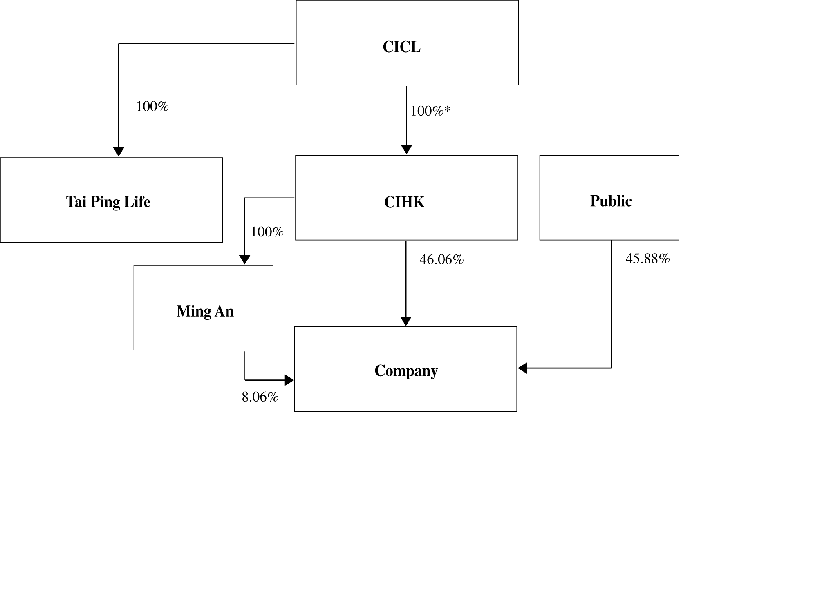
Immediately after the issuance and allotment of the Consideration Shares
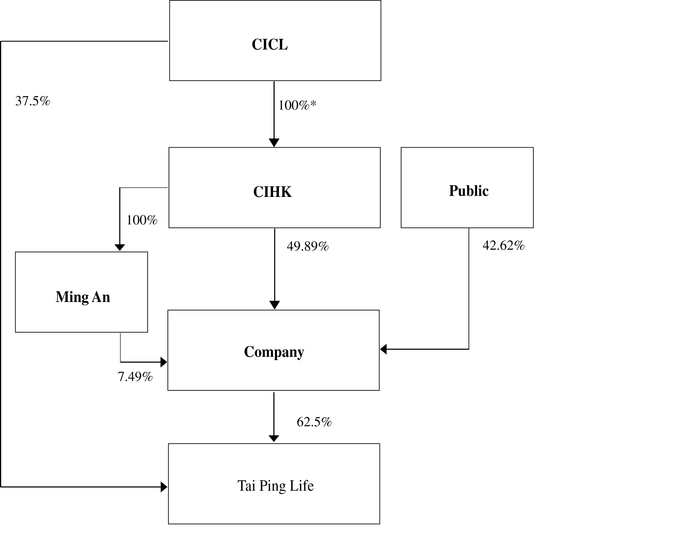
* CICL directly holds 80% of the issued shares in CIHK, while the remaining 20% of the issued shares in CIHK are held as to 10% by each of TPI and CLIC, both being CICL's wholly-owned subsidiaries

6. EGM

The EGM will be convened as soon as practicable and an ordinary resolution will be proposed to approve, among other things, the Reorganisation and Share Transfer Agreement and the transactions contemplated thereunder and the issue and allotment of the Consideration Shares. In view of the interests of CICL in the Proposed Share Transfer, CIHK and its associates (including Ming An) will abstain from voting at the EGM in respect of such resolution.

7. GENERAL

A circular containing, among other things, information on the Reorganisation and Share Transfer Agreement, the relevant accountants' report of Tai Ping Life, the letter from an independent financial adviser containing its advice to the Independent Board Committee in relation to the Reorganisation and Share Transfer Agreement, the recommendation of the Independent Board Committee in relation to the Reorganisation and Share Transfer Agreement and a notice convening the EGM referred to above will be dispatched to the Shareholders as soon as practicable.

Application will be made to the Listing Committee of the Stock Exchange for the listing of, and permission to deal in, the Consideration Shares.

8. TERMS USED IN THIS ANNOUNCEMENT

In this announcement, the following expressions have the following meanings, unless the context otherwise requires:

"Asset Transfer Agreement" the asset transfer agreement dated 29 August 2001 entered into between CICL, Tai Ping Life and CLIC regarding the transfer of the Excluded Assets to CLIC

"Asset Transfer" Transfer of the Excluded Assets from Tai Ping Life to CLIC pursuant to the Asset Transfer Agreement

"associates" has the meaning ascribed thereto under the Listing Rules

"Business Day" the days on which licensed banks in Hong Kong are normally open for business (excluding Saturdays, Sundays and public holidays)

"China Life" 中國人壽保險公司 (China Life Insurance Company), a PRC state owned company established on 22 August 1996 in the PRC under the supervision of the State Council of the PRC, and which is independent of any of the directors, chief executive and substantial shareholders of the Company or any of its subsidiaries or their respective associates

"China Re" 中國再保險公司 (China Reinsurance Company), a PRC state owned company established on 18 March 1999 in the PRC under the supervision of the State Council of the PRC, and which is independent of any of the directors, chief executive and substantial shareholders of the Company or any of its subsidiaries or their respective associates

"CICL" China Insurance Company, Limited (中國保險股份有限公司), a company established in the PRC and the ultimate holding company of the Company

"CIHK" China Insurance Hong Kong (Holdings) Company Limited, a company incorporated in Hong Kong with limited liability and a controlling shareholder of the Company which owns, directly and indirectly, approximately 54.12% of the issued shares of the Company

"CIRC" 中國保險監督管理委員會 (China Insurance Regulatory Commission), the primary regulator of the PRC insurance sector

"CLIC" 中國人壽保險股份有限公司 (China Life Insurance Company, Limited), a wholly-owned subsidiary of CICL established in the PRC

"Company" China Insurance International Holdings Company Limited, a company incorporated in Hong Kong with limited liability whose shares are listed on the Stock Exchange

"Completion" the completion of the Reorganisation and Share Transfer Agreement in accordance with its terms

"Consideration Shares" approximately 78.5 million new Shares to be issued to CIHK pursuant to the Reorganisation and Share Transfer Agreement

"Designated Subsidiary" such wholly-owned subsidiary or subsidiaries of the Company, which is or are incorporated or otherwise established outside the PRC and Hong Kong, designated by the Company to take up all or part of the 62.5% interest in Tai Ping Life pursuant to the Reorganisation and Share Transfer Agreement

"Directors" the directors of the Company, including the independent non-executive directors of the Company

"EGM" an extraordinary general meeting of the Company to be convened

"Excluded Assets" all the assets, liabilities and obligations of Tai Ping Life transferred to CLIC pursuant to the Asset Transfer Agreement, such assets, liabilities and obligations being unrelated to the life insurance business to be resumed in the PRC by Tai Ping Life

"Group" the Company together with its subsidiaries

"HK$" Hong Kong dollars, the lawful currency of Hong Kong

"Hong Kong" the Hong Kong Special Administrative Region of the People's Republic of China

"Independent Board Committee" an independent committee of the board of Directors consisting of Dr. Wu Jiesi and Mr. Lau Wai Kit

"Independent Shareholders" Shareholders other than CIHK and its associates

"Listing Rules" the Rules Governing the Listing of Securities on the Stock Exchange

"Ming An" The Ming An Insurance Company (Hong Kong), Limited, a company incorporated in Hong Kong with limited liability and a wholly-owned subsidiary of CIHK

"PICC" 中國人民保險公司 (People's Insurance Company of China), a company established in the PRC

"PRC" or "China" the People's Republic of China (excluding Hong Kong, the Macau Special Administrative Region of the People's Republic of China and Taiwan)

"PRC GAAP" generally accepted accounting principles in the PRC

"Proposed Share Transfer" the acquisition of a 62.5% interest in Tai Ping Life by the Company and/or the Designated Subsidiary pursuant to the Reorganisation and Share Transfer Agreement

"Reorganisation and Share the conditional agreement dated 4 September
Transfer Agreement" 2001 entered into between the Company, CICL and Tai Ping Life regarding, among other things, the acquisition of a 62.5% interest of Tai Ping Life by the Company and/or the Designated Subsidiary from CICL

"RMB" Renminbi, the official currency of the PRC

"SI Subsidiary" the wholly-owned subsidiary of the Strategic Investor, which is incorporated or otherwise established outside the PRC and Hong Kong, nominated by the Strategic Investor to take up all or part of the Strategic Investor Interest

"Share(s)" share(s) of HK$0.05 each in the capital of the Company

"Shareholder(s)" holder(s) of the Shares

"Stock Exchange" The Stock Exchange of Hong Kong Limited

"Strategic Investor" such non-PRC strategic investor as CICL may designate and to whom (or to the SI Subsidiary) CICL and the Company (or the Designated Subsidiary) will transfer the relevant Strategic Investor Interest and who will be independent and not connected with CICL and the Company and their associates

"Strategic Investor Interest" a total of not more than 24.9% interest in Tai Ping Life to be transferred to the Strategic Investor (or the SI Subsidiary) as to not more than 12.45 % by each of CICL and the Company (or the Designated Subsidiary)

"subsidiary(ies)" if a company controls the composition of the board of directors of another company, or controls more than half of the voting right or holds more than half of issued share capital in another company (excluding any part of it which carries no right to participate beyond a specified amount in a distribution of either profits and capital), the second mentioned company is regarded as a subsidiary of the first mentioned company

"Tai Ping" 太平保險, (Tai Ping Insurance), a domestic insurance operator established in the 1930s in the PRC, which ceased active PRC operations in the 1950s after the PRC government nationalised the domestic insurance sector under PICC

"Tai Ping Life" 太平人壽保險股份有限公司 (The Tai Ping Life Insurance Company, Limited), a PRC registered life insurance company

"TPI" 太平保險股份有限公司 (The Tai Ping Insurance Company, Limited), a wholly-owned subsidiary of CICL established in the PRC

"US$" United States dollars, the lawful currency of the United States of America

By order of the board
Miao Jianmin
Executive Director and Chief Executive Officer

4 September 2001, Hong Kong

For the purposes of illustration only, the translation of Renminbi into Hong Kong dollars is based on the exchange rate of HK$1.00 = RMB1.06 and the translation of Hong Kong dollars into United States dollars is based on the exchange rate of US$1.00 = HK$7.80. Such translations should not be construed as a representation that the amounts in question have been, could have been or could be converted at any particular rate or at all.

Please also refer to the published version of this announcement in the South China Morning Post.

