Hong Kong Exchanges and Clearing Limited and The Stock Exchange of Hong Kong Limited take no responsibility for the contents of this announcement, make no representation as to its accuracy or completeness and expressly disclaim any liability whatsoever for any loss howsoever arising from or in reliance upon the whole or any part of the contents of this announcement.

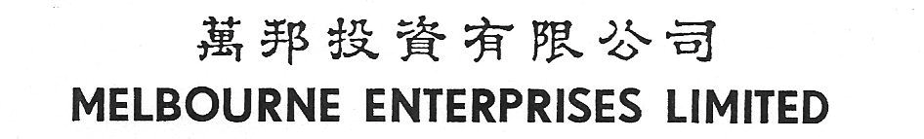
(Incorporated in Hong Kong with limited liability)

(Stock Code: 158)

POLL RESULTS OF 2022 ANNUAL GENERAL MEETING

The Board of Directors (the “Board”) of Melbourne Enterprises Limited (the “Company”) is pleased to announce that at the annual general meeting of the Company held on 20 January 2023 (the “AGM”), a poll was carried out in accordance with Rule 13.39(4) of the Rules Governing the Listing of Securities for voting on all proposed resolutions as set out in the notice of AGM dated 29 December 2022. All resolutions were approved by shareholders of the Company by way of a poll. Computershare Hong Kong Investor Services Limited, the Share Registrar of the Company, acted as scrutineer for the poll at the AGM. The poll results in respect of the resolutions proposed at the AGM were as follows:
Resolutions |  | Number of Votes (%)
 |  | For | Against
1. | To consider and adopt the audited financial statements and the Reports of Directors and Independent Auditor for the year ended 30 September 2022. | 19,749,710  (100%) | 0  (0.00%)
2. | To declare a final dividend. (A final dividend of HK$1.80 per share to shareholders registered on 31 January 2023) | 19,749,710  (100%) | 0  (0.00%)
3. | (i) To re-elect Mr. Chung Ming Fai as Director. | 19,747,910  (99.990886%) | 1,800  (0.009114%)
 | (ii) To re-elect as Mr. Tsang on Yip, Patrick Director. | 19,703,910  (99.768098%) | 45,800  (0.231902%)
 | (iii) To re-elect Mr. Chung Wai Shu, Robert as Director. | 19,747,910  (99.990886%) | 1,800  (0.009114%)
 | (iv) To re-elect Mr. Lo Pak Shiu as Director. | 19,747,910  (99.990886%) | 1,800  (0.009114%)
 | (v) To re-elect Mr. Yuen Sik Ming, Patrick as Director. | 19,747,910  (99.990886%) | 1,800  (0.009114%)
 | (vi) To authorise the Board of Directors to fix the remuneration of Directors. | 19,747,910  (99.990886%) | 1,800  (0.009114%)
4. | To re-appoint Messrs. PricewaterhouseCoopers as Independent Auditor and authorise the Board of Directors to fix their remuneration. | 19,749,710  (100%) | 0  (0.00%)
5. | Ordinary Resolution in Item No. 5 of the Notice of Annual General Meeting. (To approve a general mandate to the Directors to issue shares not exceeding 20% of the existing issued share shares) | 19,705,709  (99.777207%) | 44,001  (0.222793%)

As more than 50% of the votes were cast in favour of each of the above resolutions, these resolutions were duly passed as ordinary resolutions.

The total number of shares entitling holders to attend and vote for or against all resolutions at the AGM was 25,000,000 shares. There were no shares entitling holders to attend and vote only against the resolutions at the AGM.

By Order of the Board
CHUNG YIN SHU, FREDERICK
Company Secretary

Hong Kong, 20 January 2023

As at the date of this announcement, the Board of the Company comprises (a) three executive directors, namely Mr. Chung Ming Fai, Mr. Chung Yin Shu, Frederick and Mr. Tsang On Yip, Patrick (Mr. Kenneth Lau as his alternate); (b) one non-executive director, namely Mr. Chung Wai Shu, Robert; and (c) three independent non-executive directors, namely Mr. Lo Pak Shiu, Mr. Yuen Sik Ming, Patrick and Mr. Wong Kai Tung, Tony.

