NOT FOR DISTRIBUTION IN THE UNITED STATES

Hong Kong Exchanges and Clearing Limited and The Stock Exchange of Hong Kong Limited take no responsibility for the contents of this announcement, make no representation as to its accuracy or completeness and expressly disclaim any liability whatsoever for any loss howsoever arising from or in reliance upon the whole or any part of the contents of this announcement.

This announcement is for information purposes only and does not constitute an invitation or a solicitation of an offer to acquire, purchase or subscribe for securities or an invitation to enter into an agreement to do any such things, nor is it calculated to invite any offer to acquire, purchase or subscribe for any securities. This announcement is not an offer of securities for sale in the PRC, Hong Kong and the United States or elsewhere. The Securities are not available for general subscription in Hong Kong or elsewhere.

This announcement is not for distribution, directly or indirectly, in or into the United States (including its territories and possessions, any state of the United States and the District of Columbia). This announcement does not constitute or form a part of an offer to sell or the solicitation of an offer to buy any securities in the United States or any other jurisdiction in which such offer, solicitation or sale would be unlawful prior to registration or qualification under the securities laws of any such jurisdiction. The securities referred to herein have not been and will not be registered under the U.S. Securities Act of 1933, as amended (the “Securities Act”) and may not be offered or sold in the United States absent registration or an applicable exemption from the registration requirements of the Securities Act. No public offering of the securities referred to herein will be made in the United States.

China Huaneng Group (Hong Kong) Treasury Management Holding Limited
(中国华能集团香港财资管理控股有限公司)
(incorporated with limited liability in the British Virgin Islands)

US$500,000,000 Guaranteed Perpetual Securities
(Stock Code: 40502) (the “Securities”)
unconditionally and irrevocably guaranteed by
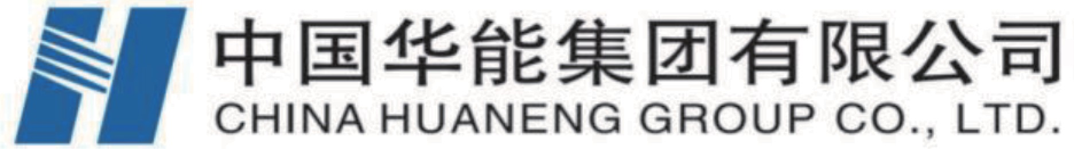

China Huaneng Group Co., Ltd.
(incorporated with limited liability in the People’s Republic of China)

NOTICE OF COMPLETION OF REDEMPTION AND WITHDRAWAL OF LISTING

Reference is made to the announcement of the Issuer dated 1 November 2023. Capitalised terms used in this announcement that are not otherwise defined have the meaning given to them in the terms and conditions of the Securities (the "Conditions").

Pursuant to condition 6(b) (Redemption at the Option of the Issuer) of the Conditions, the Issuer has redeemed all of the outstanding Securities in whole on 9 December 2023 (the “Redemption Date”), at the principal amount of the Securities together with Distributions accrued to but excluding the Redemption Date (including any Arrears of Distribution and any Additional Distribution Amount).

As at the date of this announcement, there are no outstanding Securities in issue subsequent to the redemption of the Securities on the Redemption Date. Accordingly, the Issuer has made an application to The Stock Exchange of Hong Kong Limited for the withdrawal of the listing of the Securities. Such withdrawal of listing is expected to become effective upon the close of business on 22 December 2023.

By Order of the Board
China Huaneng Group (Hong Kong) Treasury Management Holding Limited
(中国华能集团香港财资管理控股有限公司)
Cao Shiguang
Director

As at the date of this announcement, the director of China Huaneng Group (Hong Kong) Treasury Management Holding Limited (中国华能集团香港财资管理控股有限公司) is Cao Shiguang, and the directors of China Huaneng Group Co., Ltd. (中国华能集团有限公司) are Wen Shugang, Deng Jianling, Zhang Wenfeng, Xu Ping, Zhu Yuanchao, Zou Zhengping, Liu Yuzhen, and Yan Xiaopeng.

15 December 2023

