Hong Kong Exchanges and Clearing Limited and The Stock Exchange of Hong Kong Limited take no responsibility for the contents of this announcement, make no representation as to its accuracy or completeness and expressly disclaim any liability whatsoever for any loss howsoever arising from or in reliance upon the whole or any part of the contents of this announcement.
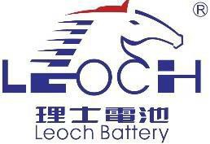

Leoch International Technology Limited
理士國際技術有限公司
(incorporated in the Cayman Islands with limited liability)
(Stock Code: 842)

DATE OF BOARD MEETING

The board of directors (the “Board”) of Leoch International Technology Limited (the “Company”) hereby announces that a meeting of the Board will be held on Tuesday, 26 March 2024 for the purposes of, amongst other matters, considering and approving the consolidated results of the Company and its subsidiaries for the year ended 31 December 2023, the publication of the final results announcement and the payment of a final dividend, if any.

By order of the Board
Leoch International Technology Limited Dr. DONG Li
Chairman

Hong Kong, 14 March 2024

As at the date of this announcement, the executive Directors are Dr. DONG Li, Ms. YIN Haiyan and Ms. HONG Yu and the independent non-executive Directors are Mr. CAO Yixiong Alan, Mr. LAU Chi Kit and Mr. LU Zhiqiang.

