Hong Kong Exchanges and Clearing Limited and The Stock Exchange of Hong Kong Limited take no responsibility for the contents of this announcement, make no representation as to its accuracy or completeness and expressly disclaim any liability whatsoever for any loss howsoever arising from or in reliance upon the whole or any part of the contents of this announcement.
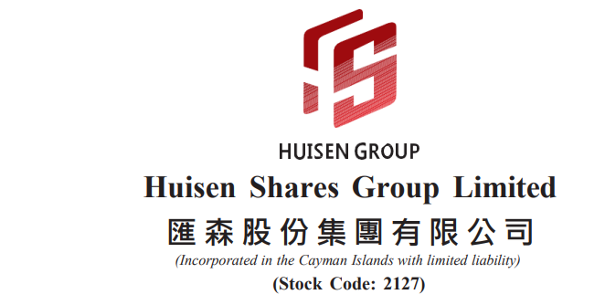
RESUMPTION GUIDANCE
AND
CONTINUED SUSPENSION OF TRADING
This announcement is made by Huisen Shares Group Limited (the “Company”, together with its subsidiaries, the “Group”) pursuant to the Inside Information Provisions (as defined in the Listing Rules) under Part XIVA of the Securities and Futures Ordinance (Chapter 571 of the Laws of Hong Kong) (“SFO”) and Rule 13.09 of the Listing Rules.
Reference is made to the announcement of the Company dated 9 June 2025 in relation to the suspension of trading in the shares of the Company on the Stock Exchange (the “Announcement”). Capitalised terms used in this announcement shall have the same meanings as defined in the Announcements unless the context otherwise requires.
RESUMPTION GUIDANCE
On 21 July 2025, the Company received a letter from the Stock Exchange setting out the following guidance (the “Resumption Guidance”) for the resumption of trading in the shares of the Company:
- conduct an independent forensic investigation with a view to identify any potential misuse or misappropriation of funds and assets, unauthorised transactions and/or Listing Rules non-compliances, including but not limited to the matters relating to the Unauthorised Transactions, the Undisclosed Claims, the Reclassifications and the Other Losses; and assess the impact on the Company’s business operations and financial position; announce the findings; and take appropriate remedial actions;
- demonstrate that there is no reasonable regulatory concern about the integrity, competence and/or character of the Group’s management and/or any persons with substantial influence over the Company’s management and operations, which may pose a risk to investors and damage market confidence;
- conduct an independent internal control review and demonstrate that the Company has in place adequate internal controls and procedures to meet its obligations under the Listing Rules;
- demonstrate the Company’s compliance with Rule 13.24; and
- inform the market of all material information for the Company’s shareholders and other investors to appraise its position.

The Company must meet all requirements in the Resumption Guidance, remedy the issues causing its trading suspension and fully comply with the Listing Rules to the Stock Exchange’s satisfaction before trading in its securities is allowed to resume. The Stock Exchange has also indicated that it may modify or supplement the Resumption Guidance if the Company’s situation changes.

Further guidance

Under Rule 6.01A(1) of the Listing Rules, the Stock Exchange may cancel the listing of any securities that have been suspended from trading for a continuous period of 18 months. In the case of the Company, the 18-month period expires on 8 December 2026. If the Company fails to remedy the issues causing its trading suspension, fulfill the Resumption Guidance and fully comply with the Listing Rules to the Stock Exchange’s satisfaction and resume trading in its shares by 8 December 2026, the Listing Division of the Stock Exchange will recommend the Listing Committee of the Stock Exchange to proceed with the cancellation of the Company’s listing. Under Rules 6.01 and 6.10 of the Listing Rules, the Stock Exchange also has the right to impose a shorter specific remedial period or to cancel the listing of the Company immediately, where appropriate.
The Resumption Guidance further stated that the Company must also comply with the Listing Rules and all applicable laws and regulations in Hong Kong and its place of incorporation before resumption.

While trading is suspended, the Company is also reminded of its obligations under the Listing Rules including, but not limited to, the following:

(a) keep the duration of any trading suspension to the shortest possible period as required under Rule 6.05 of the Listing Rules;
(b) comply with its continuing obligations under the Listing Rules at all times, for example, those applying to notifiable and/or connected transactions under Chapters 14 and 14A of the Listing Rules and publication of periodic financial results and reports and, if they are not available, management accounts under Rules 13.46 to 13.49 of the Listing Rules;
(c) announce inside information required to be disclosed under Part XIVA of the SFO; and
(d) announce quarterly updates on its developments under Rule 13.24A of the Listing Rules including, among other relevant matters:
(i) its business operations;
(ii) its resumption plan with details of actions that it has taken and intends to take to remedy the issues causing its trading suspension, fulfil the Resumption Guidance and fully comply with the Listing Rules and resume trading. The resumption plan should be accompanied with a clear timeframe in respect of each stage of work under the plan with a view that the Resumption Guidance can be fulfilled and trading can resume as soon as practicable and, in any event before the 18-month period expires; (iii) the progress of implementing its resumption plan; and
(iv) details of any material change to the resumption plan and, in the case of delay, the reasons and impact of such delay.

The Resumption Guidance further stated that it is the Company’s primary responsibility to devise its own resumption plan with a timetable setting out the actions that it considers appropriate to fulfil the Resumption Guidance and comply with the Listing Rules, work according to the plan, and announce quarterly updates. Whilst the Company may seek the Stock Exchange’s guidance on its resumption plan, its resumption plan is not subject to the Stock Exchange’s prior approval before implementation.

When the Company considers that it has fulfilled the resumption, remedied the issues causing its trading suspension and fully complied with the Listing Rules, it should request the Stock Exchange’s confirmation that this is the case and provide the Stock Exchange with sufficient supporting information for assessment.

The Company is taking appropriate steps to resolve the issues causing its trading suspension and to fully comply with the Listing Rules to the Stock Exchange’s satisfaction, and will seek to resume trading in its shares as soon as possible.

The Company must announce the first quarterly update on or before 8 September 2025 and quarterly updates every three (3) months from that date until resumption or cancellation of listing (whichever is earlier).

CONTINUED SUSPENSION OF TRADING
Trading in the Company’s shares on the Stock Exchange has been suspended since 9 June 2025 and will remain suspended until further notice. Further announcement(s) will be made by the Company as and when appropriate and in accordance with the requirements of the Listing Rules to keep its shareholders and potential investors informed of the latest progress in complying with the Resumption Guidance.
Shareholders and potential investors should exercise caution when dealing in the securities of the Company.

By order of the Board
Huisen Shares Group Limited
Wu Runlu
Chairman

Hong Kong, 28 July 2025

As at the date of this announcement, the Board comprises Mr. Wu Runlu and Ms. Zeng Minglan as executive directors, Mr. Ngok Ho Wai and Mr. Liu Jiong and Mr. Feng Zhaowei as independent non-executive directors.

