Hong Kong Exchanges and Clearing Limited and The Stock Exchange of Hong Kong Limited (the “Stock Exchange”) take no responsibility for the contents of this announcement, make no representation as to its accuracy or completeness and expressly disclaim any liability whatsoever for any loss howsoever arising from or in reliance upon the whole or any part of the contents of this announcement.

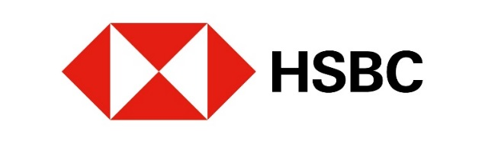

Notice of Occurrence of Mandatory Call Event and Early Expiry of
European Style (Cash Settled) Category R Callable Bull/Bear Contracts
(the “CBBCs”)

issued by

The Hongkong and Shanghai Banking Corporation Limited
(Incorporated in Hong Kong with limited liability under the Companies Ordinance of Hong Kong)

Non-collateralised Structured Products

All capitalised terms not defined in this announcement have the same meaning as defined in the terms and conditions of the CBBCs (the "Conditions").

The Hongkong and Shanghai Banking Corporation Limited (the “Issuer”) announces that a Mandatory Call Event (“MCE”) in respect of the CBBCs described in the table below has occurred, or is deemed to have occurred, on the date (the "MCE Date") specified in the table below, and the CBBCs have automatically expired. Subject to the Conditions, trading in the CBBCs on the Stock Exchange has been suspended by the Stock Exchange on behalf of the Issuer and the CBBCs shall be delisted after the close of business of the Stock Exchange on the MCE Termination Date. The Issuer will pay to each CBBC Holder (as shown in the register kept by or on behalf of the Issuer on the MCE Termination Date) the Residual Value (if any) in respect of each Board Lot of CBBCs held by the CBBC Holder in accordance with the Conditions on the Settlement Date.

Market participants (“MPs”) may also refer to the Issuer’s website at https://www.warrants.hsbc.com.hk/en/index and the Stock Exchange’s website at https://www.hkex.com.hk/eng/cbbc/mce/mcetoday.htm on the MCE Termination Date for information on the MCE Date.

Payment of the Residual Value (if any) shall constitute full and final settlement of the obligations of the Issuer with respect to the CBBCs. Subject to such payment having been made, the Issuer shall have no obligation towards the CBBC Holders under the CBBCs subsequent to the MCE Termination Date.

MPs should note that all Post MCE Trades will not be recognised and will be cancelled by the Stock Exchange either on the MCE Termination Date or on the immediately succeeding Trading Day. References to “Post MCE Trades” means, subject to such modification and amendment prescribed by the Stock Exchange from time to time, all trades concluded after the MCE.

Relevant participants of the Stock Exchange ("EPs") involved in any Post MCE Trades may refer to a trade file disseminated by the Stock Exchange via the Stock Exchange's Electronic Communication Platform for additional details on the MCE. Such EPs must check their trades against the MCE Date and advise their clients of any cancelled trades in the CBBCs. If there are any discrepancies, these must be reconciled with the Stock Exchange as soon as possible.

Stock Code | Type | MCE Date (New York)¹ | Issue Size  (CBBCs) | Underlying
49797 | BEAR | 6-Feb-26 | 100,000,000 | Dow Jones Industrial Average Index

Hong Kong, 9 Feb 2026

In respect of the relevant series of CBBCs where the closing level of the Index as compiled and published by the Index Compiler in respect of the Index Business Day immediately preceding the Observation Commencement Date (which is deemed as the Spot Level of the Index as at 9:00a.m. (Hong Kong time) on the Observation Commencement Date) is at or below (in respect of a series of bull CBBCs) or at or above (in respect of a series of bear CBBCs) the Call Level. Accordingly, the MCE is deemed to have occurred as at 9:00a.m. (Hong Kong time) on the Observation Commencement Date.

