Hong Kong Exchanges and Clearing Limited and The Stock Exchange of Hong Kong Limited (the “Stock Exchange”) take no responsibility for the contents of this announcement, make no representation as to its accuracy or completeness and expressly disclaim any liability whatsoever for any loss howsoever arising from or in reliance upon the whole or any part of the contents of this announcement.

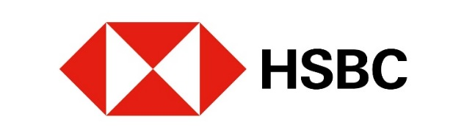

Notice of Occurrence of Mandatory Call Event and Early Expiry of
European Style (Cash Settled) Category R Callable Bull/Bear Contracts
(the “CBBCs”)

issued by

The Hongkong and Shanghai Banking Corporation Limited
(Incorporated in Hong Kong with limited liability under the Companies Ordinance of Hong Kong)

Non-collateralised Structured Products

All capitalised terms not defined in this announcement have the same meaning as defined in the terms and conditions of the CBBCs (the "Conditions").

The Hongkong and Shanghai Banking Corporation Limited (the “Issuer”) announces that a Mandatory Call Event (“MCE”) in respect of the CBBCs occurred in the pre-opening session, the continuous trading session or the closing auction session (as the case may be) of the Stock Exchange at the time (the “MCE Time”) specified in the table below on 09 Feb 2026 (the "MCE Date") and the CBBCs have automatically expired. As a result, trading in the CBBCs on the Stock Exchange has been suspended by the Stock Exchange on behalf of the Issuer and the CBBCs will be delisted after the close of business on the MCE Date. The Issuer will pay to each CBBC Holder (as shown in the register kept by us on the MCE Date) the Residual Value (if any) in respect of each Board Lot of CBBCs held by the CBBC Holder in accordance with the Conditions on the Settlement Date.

Market participants (“MPs”) may also refer to the Issuer’s website at https://www.warrants.hsbc.com.hk/en/index and the Stock Exchange’s website at https://www.hkex.com.hk/eng/cbbc/mce/mcetoday.htm on the MCE Date for information on the MCE Time.

Payment of the Residual Value (if any) shall constitute full and final settlement of the obligations of the Issuer with respect to the CBBCs. Subject to such payment having been made, the Issuer shall have no obligation towards the CBBC Holders under the CBBCs subsequent to the MCE Date.

MPs should note that all Post MCE Trades will not be recognised and will be cancelled by the Stock Exchange either on the MCE Date or on the immediately succeeding Trading Day. References to “Post MCE Trades” mean (i) if a MCE occurred in the pre-opening session of the Stock Exchange, all auction trades in the CBBCs concluded in the pre-opening session and all manual trades concluded after the end of the pre-order matching period in such session and (ii) if a MCE occurred in the continuous trading session of the Stock Exchange, all trades in the CBBCs concluded via auto-matching or manually after the time of the occurrence of the MCE. For the avoidance of doubt, if a MCE occurred in the closing auction session of the Stock Exchange, there are no Post MCE Trades.

Relevant participants of the Stock Exchange ("EPs") involved in any Post MCE Trades may refer to a trade file disseminated by the Stock Exchange via the Stock Exchange's Electronic Communication Platform for additional details on the MCE. Such EPs must check their trades against the MCE Time and advise their clients of any cancelled trades in the CBBCs. If there are any discrepancies, these must be reconciled with the Stock Exchange as soon as possible.

Stock Code | Type | MCE Time | Issue Size  (CBBCs) | Underlying
58141 | BEAR | 14:46:50 | 200,000,000 | Hang Seng Index

Hong Kong, 09 Feb 2026

